How to Search 500 Square Kilometres in 10 minutes
The LoRa Relay
Of all the LoRa programs I have written, the relay program is by far the most significant, the impact it can have on long range locating is monumental, and it’s a very simple program.

A lot of trackers use a fairly bulky receiver, either a portable UHF transceiver or custom made receivers as used by the wildlife trackers. At ground level a ‘lost’ tracker, be it a Radio Controlled (RC) model, landed high altitude balloon or model rocket, could be just too far way to receive good signals. What can very significantly improve search range is increasing the altitude above ground of your receiver, especially in urban areas.

It is often not practical to put a (large) hand-held LoRa receiver at height. A good location in an urban area for a receiver may well be on the roof of a house or up a tree but how do you get all the kit up there?
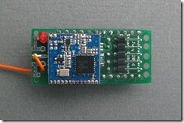

The simple answer is that you don’t have to, you put the relay ‘up there’ instead. The relay listens for packets coming from the ‘lost’ model or balloon and then retransmits them so you can pick them up on your normal LoRa receiver on the ground. The relay is small light, and self contained.

Using a bit of string and a weight, a small rubber ball is good a stone is not, it is only a few minutes work to get a line over a house or tree and pull the relay up. If you carry a long extensible pole, also useful for rescuing models from trees, put the relay on that, the extra 10M or so of height can make a real difference.

Apart from using a handy nearby mountain, one other way with for a tracker receiver to get a good line of sight above a tracker ‘lost’ on the ground is to hire a person carrying aeroplane or helicopter, perhaps not too practical.

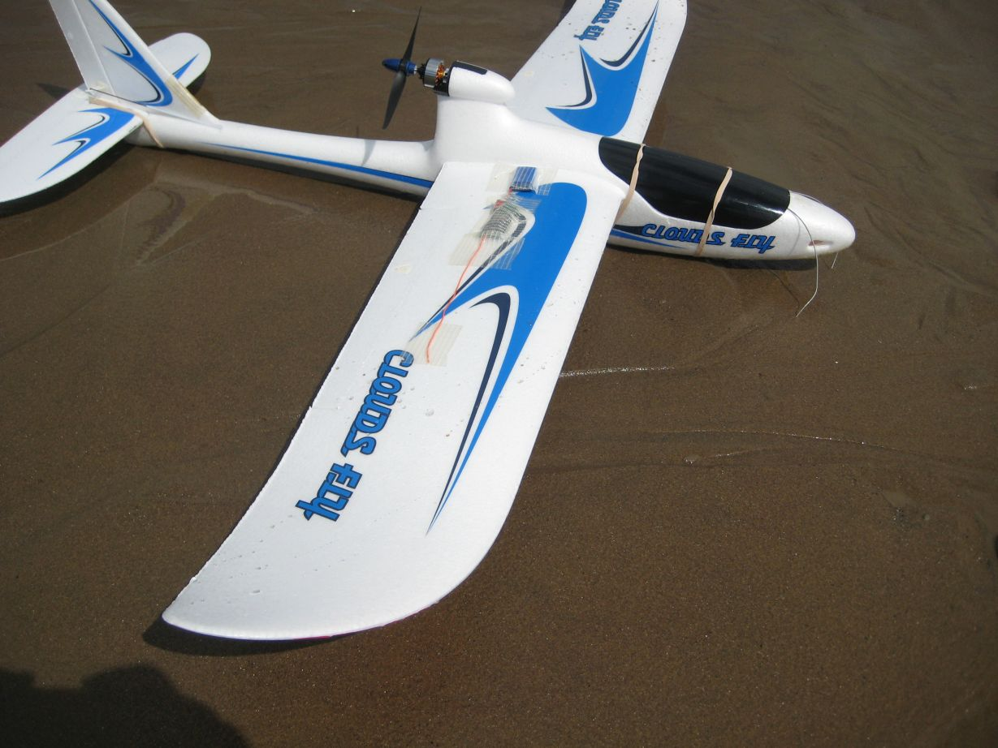
My LoRa trackers are small and light and specifically designed to be carried in (small) model aeroplanes or copters. The tracker transmitter is a receiver as well and can act as a telemetry relay. In this mode the relay (on the plane or copter) listens for incoming telemetry and then re-transmits the packets down to the ground. Range from the plane to the ground is no issue, since the plane is not that far away and you have good line of sight to it.

So to test the relay I taped it to a small easy build and low cost plane, an AXN Floater.

I then left the tracker transmitter at home in the garden and went to the beach.
In 1897 Marconi used the height of the cliffs at Lavernock point to demonstrate the first radio communications over water. Over a hundred years later I was at the same spot, C on the map and the picture below, 12km from the tracker transmitter in my garden.

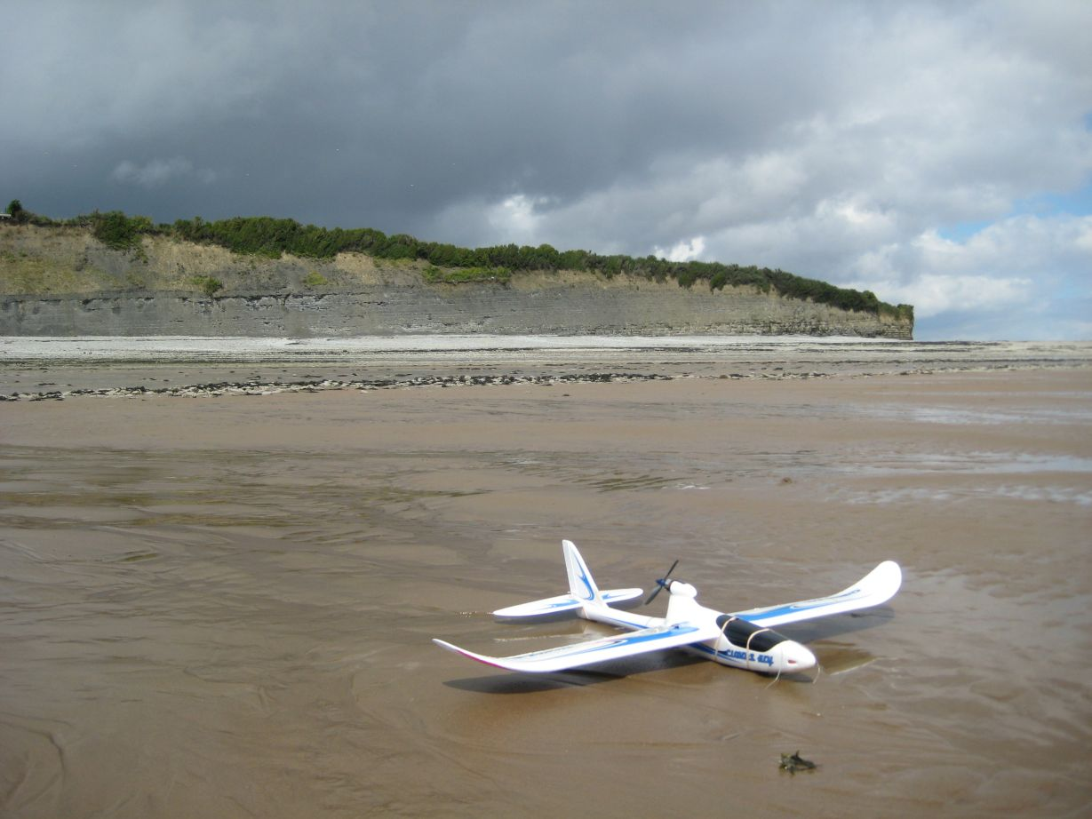

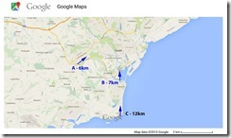

Would I be able to pick up the tracker transmitter from this spot?

I launched and flew the plane up to altitude. In a few seconds and at around 100M up
The relay had picked up the telemetry from the transmitter. Success! I was able to pick up the trackers transmissions, and hence location, across 12km+ of urban environment and countryside. In about ten minutes I had covered a search area of 500 square kilometres, imagine how long that would take to search at ground level !!!

The potential here is clear, with a simple Radio Controlled plane or copter and the
right software you can dramatically increase your search range. Flying higher and
fitting a better antenna on the search plane could increase the range even further.
The LoRa trackers used in the tests above were Hope RFM98s, running at 10mW. The
device is capable of 50mW, which if used should double the range.

An alternative to using a RC model to get the relay to altitude is to use a kite, the relay is light enough.

Stuart Robinson
August 2016

